Report on the discussions about Health and Care Plan improvements to local services and improvements to outpatients at St George’s Hospital.
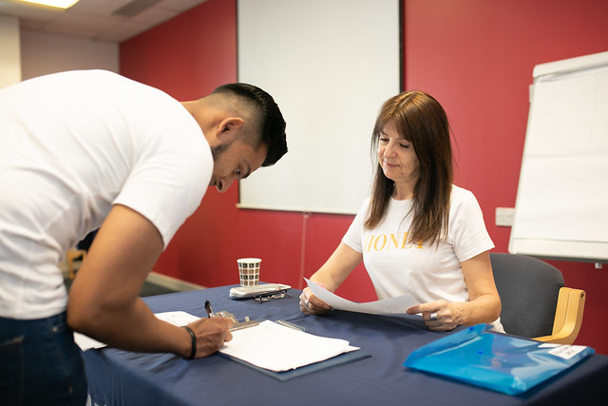
Introduction
At our public event on Wednesday 22 May 2019 we discussed improvements to local services including the Outpatients departments at Queen Mary’s and St George's hospitals. We wanted to hear about plans that service leaders have for change and to hear from local people about their thoughts and priorities relating to the plans.
27 people took part in the discussions. Feedback was given directly to presenters in the room who have the power to act on the issues discussed.
Plans to improve local services
Josh Potter, Local Director of Commissioning for the Merton and Wandsworth NHS Local Delivery Unit presented the new Wandsworth Health and Care Plan, a plan developed between health and care services to try and make a difference together on important health priorities. Josh presented some key points in the plan and asked our audience to discuss the plan and provide some feedback.
We discussed the following questions:
1. Is there anything missing in our actions that you would expect to see in the Health and Care Plan?
2. And have you any other comments about the Health and Care Plan discussion document?
Here is a summary of some common themes and suggestions from local people who attended our event.
Patient involvement in the generation of the plan:
There were questions about how the plan was devised, if there was any patient and public involvement, and how it would be disseminated. People highlighted a need for the following to enable as many people as possible to be involved:
- Paper copies to be available for those who need them.
- An easy read version to be available.
- The need to listen to patients and people using services should be incorporated into the plan: “the importance of our voice does not come across”.

How the plan approaches improving health of different sections of the community:
Josh Potter explained the vision behind the plan:
“We want people to remain as healthy as they can for as long as they can and the priorities within our plan run throughout the life course. Our partnership approach is focused on prevention, integration and supporting local communities to become more resilient.”
The plan is divided into different sections:
Start Well - We want children to be healthy from the start so they can grow up to be healthy adults achieving their full potential. We are concerned about risky behaviours, obesity and mental wellbeing in young people.
Live Well - We know that there is no physical health without mental health and integrating our approach to physical and mental health is a priority. We want people with long term conditions to be able to help themselves and Diabetes is a specific concern we want to explore.
Age Well - We want to join up health and social care services to provide a better service to residents. We want to continue to increase awareness and early diagnosis of Dementia and look at social isolation amongst older people.

People at our event felt that this structure might be artificial and did not take into consideration issues that affect people across their lifespan, for example:
- Social isolation was only mentioned as an issue for older people, whilst,
- Talk Wandsworth was not mentioned as a service for later life.
There seemed to be a feeling that the plan did not pay enough attention to themes and services that affect everyone, for example:
- The role of therapists as the ‘glue between services’ and their key role in coordination of care and integration between health and social care.
- The need for prevention to be mentioned at every stage.
- The need to tackle inequalities across the plan.
- The role of person-centred care that ‘joins the dots between services’.
- The vital role that transport plays for many people.
- The need to promote services to those who need them most.
People felt that some groups of service users and service providers were missing from the plan. These included:
- People with Learning Disabilities – in particular, support for people with learning disabilities to attend appointments.
- Dentists and opticians.
- School nurses (to link with obesity services).
Implementation of the plan
There was a suggestion for alignment with Richmond plans.
People at the Assembly stressed the importance of putting the plan into action. They wanted to hear about practical measures and raised the following questions:
- How do you realistically tackle social isolation?
- How do you identify risky behaviours? And how will those affected be involved?
- How do the people who need the services most know that help exists?
- What are you actually going to be doing for the elderly disabled people?
- It was highlighted that phrases like ‘Make Every Contact Count’ needed explanation of how they will make a difference in practice.
Specific services and issues were also mentioned, including:
- The need for a Mental health drop-in in Roehampton because its location means it is difficult for residents to get to other services.
- New mum’s mental health.
- The physical accessibility of the Talk Wandsworth building, and the time-limited nature of their services.
- The issue of drug gangs in Roehampton was given as an example of where action is needed in terms of risky behaviours.
The importance of the way health and social care services are ran and the workforce supported and trained.
For example:
- People felt that services should ‘led by example’. There was a query as to whether services and partner organisations would qualify for the Healthy Workplace Charter.
- There was a suggestion that non-clinical staff need education about the services available.
- There was a suggestion that more communication training is needed.
- There was a query about how the inadequate provision of transport for health appointments will be addressed.
- Concerns about outsourcing were raised. (The response from Josh Potter was that an out-sourced service is contracted, monitored and governed in exactly the same way as an NHS service.)

Developments to Outpatients services and discussion

Rob Game introduced himself as the new Director for Outpatients for St George’s and Queen Mary’s Hospitals. He told us about how outpatient services have been improved recently and listed some ideas for future changes.

There were two specific ideas which Rob presented and wanted to hear what people thought about them.

We discussed the following questions and you will find a summary of the themes below.

1.Outpatients are developing specialist services & responding to population need; capacity will be freed up to develop/grow our more specialist services, and provide an outpatient offering more responsive to the needs of patients.
What would you like to see and where?
Specific services were mentioned:
- Sexual health services.
- The availability of blood tests / phlebotomy services was of concern. People felt that:
- The blood testing facilities at the hospital should have longer hours.
- Blood testing facilities should be available in more GP surgeries.
Some examples of out-patients services that were considered good were mentioned:
- The Nelson ‘clinic’ was highlighted as good example on many points. It was highlighted that it acts as a ‘satellite’ centre to pick up some of the appointments needed by a lot of people to clear the waiting list for specialist doctors and that this could be a useful model.
- One stop shop ‘St Georges Hospital’.
Location:
People felt that services should be local and not dependant on the postcode of the hospital.
Practical considerations:
Many people spoke about the practicalities around attending outpatient services:
- One issue that arose was the need for good administration of appointments.
- Not to have appointments at different clinics that clash.
- To have clear communication about cancelled appointments.
- Not to be classed as ‘did not attend’ if they had to cancel an appointment.
- Not to be sent to different sites or parts of the hospital.
- To have reduced waiting times.
- To have NHS IT systems that ‘talk’ to each other.
- Help with transport.
- People saw a role for the GP in co-ordinating outpatient care:
- To co-ordinate different appointments.
- To follow-up after appointments.
- Staffing was also mentioned. People felt that:
- “It all depends on the availability of staff.”
- There should be more radiographers.
- Quality of staff is important.
Additional consideration of needs:
There was also a feeling that the needs of different people and teams supporting people with additional needs should be taken into account, in particular:
- The role of disability navigators.
- St George’s disability team.
- People who are hearing impaired.
- The need for transport.
2. Digitalising outpatient services – there is potential for greater use of virtual appointments, virtual triage, bookings and communication, all contributing to more efficient, more responsive and safer care.
What could be improved? What would you like to see and where?
In general, people attending the assembly were sceptical of the use of technology, although there were a few positive suggestions and examples.
Clearly where people may have concerns, it would be important to explain if people had a choice to use digital services or other types of services, and it should be explained how the technology might work and use their data.
Here is a summary of some of the issues people highlighted.
People thought that use of technology would restrict access to services:
- Technology is seen as a barrier to services, especially for the elderly and those who need services most.
- “If they make everything digital I ‘won’t bother’”
- There were concerns that use of technology would increase social isolation.
- There was a suggestion that patients might need training to use IT systems.
There were also concerns about the safety of using IT systems around:
- The need for data protection consent to share information.
- A feeling that using IT systems ‘creates errors’.
People wanted to keep more ‘traditional’ ways of accessing services:
- There ‘should always be a different option’.
- More can be done by phone.

